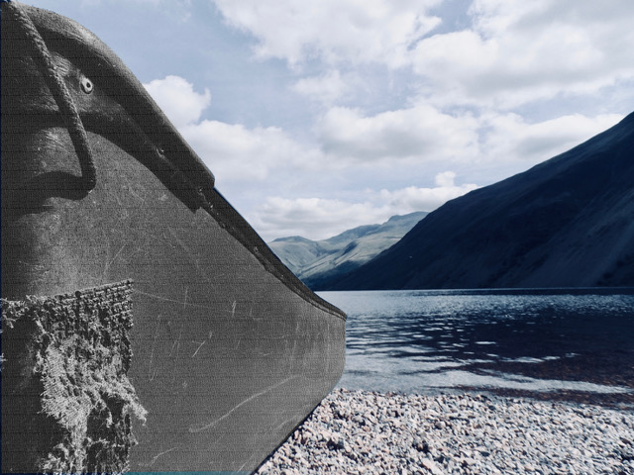

The story Part 6

A summary of the *Canoeing the Mountains* image

We have heard in the previous workshop(s) that Lewis and Clark clearly recognise the value of Sacagawea, the Shoshone Indian wife of one of their party, despite the fact that culturally they would not have been expected to pay her any attention. They knew that that they needed her knowledge of the land. They needed her help to find her people, and her people’s help to find their way through the mountains. The success of the expedition depended on the help of strangers.

The day after Lewis had finally found the source of the Missouri - and at the same time realised how extensive the mountains were – he set off again in search of the Shoshone people. By now he knows well that the different Indian tribes are frequently hostile to one another. When he does catch sight of one of them he calls out the word *tab-ba-bone*, which means ‘white man’ in their language. Eventually he sees a small group ahead, firstly a man who watches him approach but then runs back the way he had come, then two women with a child. The younger woman also runs off, leaving an old woman and girl of about 12 years. These two sit down on the ground, clearly alarmed and expecting the worst. Lewis describes what happened:

“I took the elderly woman by the hand and raised her up, repeated the word *tab-ba-bone* and stripped my shirt sleeve to show her my skin; to prove to her the truth of the assertion that I was a white man, for my face and hands which have been constantly exposed to the sun were quite as dark as their own.”[1]

Lewis gives them some beads and trinkets. The women are evidently relieved, and the one who had run away came back. Lewis goes on, “I now painted their tawny cheeks with some vermillion which with this nation is emblematic of peace.” (Imagine doing that to strangers you might meet on the streets here in Cumbria!) Through sign language, Lewis is able to indicate that he would like to be taken to the chiefs and leaders of their people. After walking for a couple of miles they are met by about 60 Shoshone warriors – word had gone ahead about the appearance of the white men. It is worth hearing how they met.

“When they arrived I advanced towards them with the flag, leaving my gun with the party about 50 paces behind me. The chief and two others who were a little in advance of the main body spoke to the women, and they informed them who we were and exultingly showed the presents which had been given them. These men then advanced and embraced me very affectionately in their way, which is by putting their left arm over your right shoulder, clasping your back, while they apply their left cheek to yours and frequently vociferate the word *a’h-hi-e, a’h-hi-e*, that is, I am much pleased, I am much rejoiced. Both parties now advanced and we were all caressed and besmeared with their grease and paint till I was heartily tired of the national hug.”[2]

He goes on to describe a pipe smoking ritual, which is repeated when they arrive at the Indian camp. The relationship that develops in those moments leads to the sharing of food, the lending of horses, and the finding of a guide through the unexpected landscape. This only happens because Lewis took the risk of being vulnerable, acknowledged his dependency, and above all, showed respect for and behaved according to the etiquette of strangers.

1. Landon Y. Jones, ed., *The Essential Lewis and Clark*, HarperCollins, 2000. p.81
2. As above, p.83