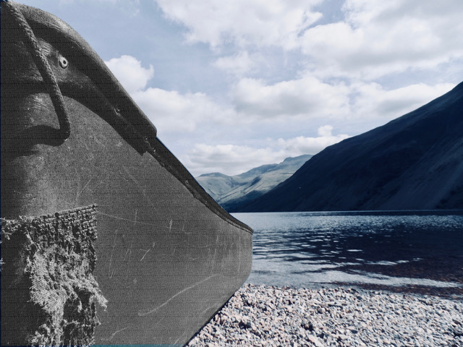

The story Part 7

A summary of the *Canoeing the Mountains* image

After spending the winter at Fort Mandan the party is ready to move on and Lewis is in good spirits and full of excited anticipation for the journey that lay ahead.

On 7th April 1805 he writes:

“The party are in excellent health and spirits, zealously attached to the enterprise, and anxious to proceed; not a whisper or a murmur of discontent to be heard among them, but all act in unison, and with the most perfect harmony.”[1]

At times the cliffs at the side of the river left little room for scrambling on dry land. In Lewis’s journal entry for 30th May 1805 we read:

“The obstruction of rocky points and riffles still continue as yesterday; at those places the men are compelled to be in the water even to their armpits, and the water is very cold, and so frequent are these points that they are one fourth of their time in the water. …and in that situation dragging the heavy burden of a canoe and walking occasionally for several hundred yards over the sharp fragments of rocks which tumble from the cliffs and garnish the borders of the river; in short their labour is incredibly painful and great, yet those faithful fellows bear it without a murmur.”[2]

Just over three weeks later the landscape is different again. They are travelling through prairie lands, inhabited by many buffalo. Following heavy rain the land is now dry, which presents a new problem. The ground once churned up by buffalo is now baked hard, leaving a multitude of unavoidable sharp points of earth. On 23rd June 1805 Lewis comments:

“This is particularly severe on the feet of the men who have not only their own weight to bear in treading those hackle-like points but have also the addition of the burden which they draw and which in fact is as much as they can possibly move with. They are obliged to halt and rest frequently for a few minutes. At every halt these poor fellows tumble down and are so much fatigued that many of them are asleep in an instant. In short, their fatigues are incredible; some are limping from the soreness of their feet, others faint and unable to stand for a few minutes, with heat and fatigue, yet no one complains. All go with cheerfulness.”[3]

Perfect harmony? Bearing hardships without a murmur? Cheerfulness in the midst of pain and exhaustion? It might seem extraordinary, but at the heart of this is a crucial aspect of team cohesion. Part of Lewis and Clark’s original plan had been to reduce the size of the party at around this time, sending some men back to St. Louis with a further progress report. One concern they had was that if they were too large a group they might appear to the native Indians to be aggressors and not people of peace. They decided not to do this however, partly because of concluding that they were already a small enough group. More importantly however, they were concerned that it would disrupt the cohesion of the team.

A last extract from Lewis’s journal, this time for the 4th July 1805:

“We fear also that such a measure might possibly hazard the fate of the expedition. We have never once hinted to any one of the party that we had such a scheme in contemplation, and all appear perfectly to have made up their minds to succeed in the expedition or perish in the attempt.”

Every member of the team was committed to its success.

1. Landon Y. Jones, ed., *The Essential Lewis and Clark*, HarperCollins, 2000. p.33
2. As above, p.51
3. As above, p.69