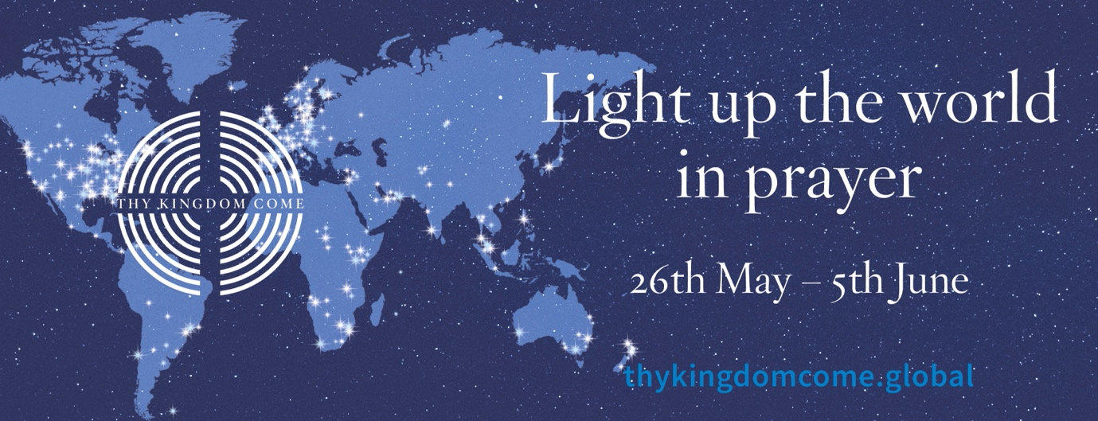

Resources for Thy Kingdom Come 2022

In this document we’ve highlighted some key resources for TKC, including new material for 2022 and a section on publicity. Much more information on these and other resources is available at www.thykingdomcome.global

Resources for Adults

Daily Prayer

Two new resources written by the Archbishop of Canterbury:

- Prayer Journal 2022 - short daily reflections on a different biblical image of the Holy Spirit, and space to write prayers for your five people

- Novena 2022 - nine days of reflections on verses from the book of 1 Peter, accompanied by inspiring artwork

View and download both at: https://www.thykingdomcome.global/prayer-resources
Printed copies can be purchased at: www.chpublishing.co.uk/thykingdomcome
Available in Large Print at: https://www.cpo.org.uk/search.aspx?q=thy+kingdom+come

Audio Reflections

- Lectio 365 - Daily audio reflections led by Justin Welby and members of the 24-7 Prayer team, available at: https://www.24-7prayer.com/resource/lectio-365/

Video reflections

- TKC Daily Video reflections - from a variety of contributors. Will be available at: https://www.thykingdomcome.global/videos and https://vimeo.com/showcase/8467262

Resources for Families

Daily audio reflections

- Lectio for Families - daily audio reflections on 24-7 Prayer’s Lectio for Families app at: www.24-7prayer.com/resource/lectioforfamilies/
Creative ideas for praying at home

- Bright Prayer Ideas for families at home - available at:
www.thykingdomcome.global/resources/bright-ideas-resources

Resources for Young People

The Way UK
- Videos - New video series on Prayer produced by The Way, with accompanying discussion plans. Available at: www.youtube.com/playlist?list=PL8MWRKUMxYC25dkbxoYaLb19zfT2u6vF3

- The Way can be followed at their social channels:

Instagram @thewayuk: https://www.instagram.com/thewayuk
TikTok @thewaytv: https://www.tiktok.com/@thewaytv
YouTube /TheWayChannel: https://www.youtube.com/c/TheWaychannel

Resources for Children

Cheeky Pandas

- Cheeky Pandas Videos - a new cartoon series for 2022 to help children grow in their faith, based on the Fruit of the Spirit. Each episode is accompanied by an Activity pack and an Assembly plan for schools.

Available at: https://cheekypandas.com/cheeky-pandas-series/

- Cheeky Pandas Book - Queen CJ and the Bouncy Castle. To celebrate the Queen’s Platinum Jubilee, a story on the theme of God’s faithfulness.
Available to buy at: https://www.chpublishing.co.uk/features/thy-kingdom-come

Resources for Churches - Praying Together

Creative ideas and resources for corporate prayer

- Upper Room - run a Prayer Room / Continuous prayer. Guidance for setting up your prayer room at: https://www.thykingdomcome.global/resources/continuous-24-hour-prayer

- Postcard Project - Connect with your local community by posting a ‘prayer postcard’ into
nearby homes and encouraging them to send in prayer requests

“Praying for You” prayer cards available at: https://www.cpo.org.uk/thykingdomcome

- Stations of the Cross using 2022 Novena artwork - view and download at: https://www.thykingdomcome.global/resources/resources-prayer-stations

- Bright Prayer Ideas for your Church - lots more ideas available at:
www.thykingdomcome.global/resources/bright-ideas-resources

Publicising and launching Thy Kingdom Come in your church

- Video - Create your own TKC video to promote your prayer event. A step-by-step guide is available at Go Chatter Videos:

www.thykingdomcome.global/stories/how-create-your-own-customised-thy-kingdom-come-video

- TKC Social Media Graphics & Banners - available at:

https://www.thykingdomcome.global/resources/2022-social-media-graphics-banners

- A short Act of Commissioning - new for 2022, a short liturgy designed to be included in services on Sunday, 22nd May:

https://www.thykingdomcome.global/sites/default/files/2022-02/TKC%20Commissioning.pdf

